Ex.No.16 VOTER RECORD CHECKER
INTRODUCTION:
- This Voter Record Management System is a desktop-based Java application designed to simplify the process of managing voter information.
- It allows users to perform essential operations such as adding, searching, viewing, and deleting voter records efficiently.
- The system uses a client-server architecture, where the client communicates with the server using socket programming.
- The project demonstrates how computers can manage and exchange structured data across networked systems in real time.
- It ensures accuracy and consistency in voter data by implementing input validation and age restrictions.
- The graphical user interface (GUI) is developed using Java Swing, offering an interactive and user-friendly experience.
- It showcases important Java concepts such as event handling, multithreading, and network communication.
- The application eliminates manual record-keeping, making voter management faster and more reliable.
- It serves as a practical learning example for students exploring network programming and GUI design in Java.
- Overall, this project demonstrates how technology can be effectively used to build reliable, connected systems for real-world data management.
PROJECT DESCRIPTION:
- This Analog Clock project is a simple desktop-based application designed to visually represent the current time using an analog-style clock interface.
- It displays the hour, minute, and second hands that move in real time to reflect the system clock.
- The clock is built using Java’s Swing and AWT libraries, utilizing shapes such as lines and circles to form the clock’s structure and hands.
- The program dynamically updates the hands every second, simulating the smooth and continuous motion of a traditional analog clock.
- The design ensures accuracy in time representation while maintaining a visually appealing and minimalistic interface.
- Developed using object-oriented programming principles, the project demonstrates the use of Java graphics, event handling, and real-time drawing techniques.
- It serves as an excellent example for understanding GUI-based animation, timer implementation, and basic geometry in Java programming.
- Overall, the Analog Clock project provides a simple yet effective illustration of how visual components can be used to create functional, real-time desktop applications.
SYSREM ARCHITECTURE:

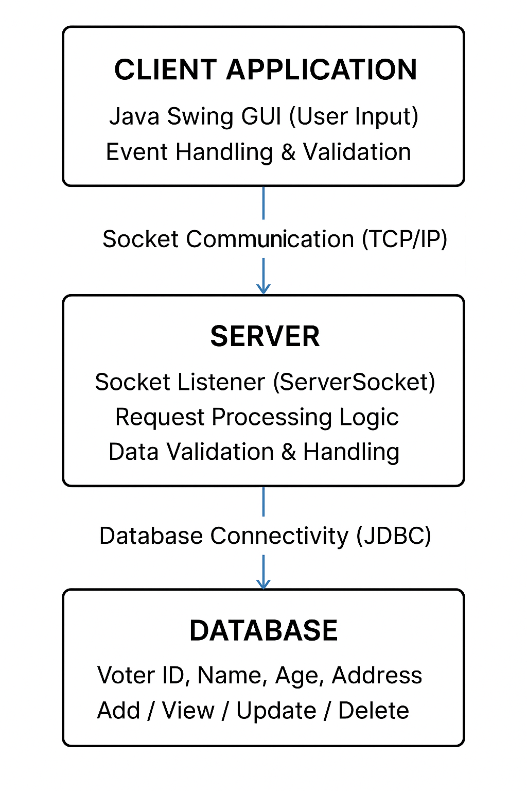

IMPLEMENTATION OF CODE:
DBManager.java:
package giri;
import javax.swing.*;
import java.awt.*;
import java.io.*;
import java.net.Socket;
public class VoterRecordUI extends JFrame {
private JTextField idField, nameField, ageField;
private JTextArea displayArea;
private static final String SERVER_HOST = "localhost";
private static final int SERVER_PORT = 5000;
public VoterRecordUI() {
setTitle(" Voter Record Management System");
setSize(780, 540);
setDefaultCloseOperation(JFrame.EXIT_ON_CLOSE);
setLocationRelativeTo(null);
setLayout(new BorderLayout(15, 15));
Color lightPink = new Color(255, 228, 235); // uniform soft pink
Color deepPink = new Color(197, 27, 111); // bold accent pink
getContentPane().setBackground(lightPink);
JLabel header = new JLabel("Voter Record Management System", SwingConstants.CENTER);
header.setFont(new Font("Poppins", Font.BOLD, 22));
header.setForeground(deepPink);
header.setBorder(BorderFactory.createEmptyBorder(15, 0, 10, 0));
add(header, BorderLayout.NORTH);
JPanel formPanel = new JPanel(new GridBagLayout());
formPanel.setBackground(lightPink);
formPanel.setBorder(BorderFactory.createCompoundBorder(
BorderFactory.createLineBorder(deepPink, 1),
BorderFactory.createEmptyBorder(20, 25, 20, 25)
));
GridBagConstraints gbc = new GridBagConstraints();
gbc.insets = new Insets(8, 8, 8, 8);
gbc.fill = GridBagConstraints.HORIZONTAL;
JLabel lblId = new JLabel("Voter ID:");
JLabel lblName = new JLabel("Name:");
JLabel lblAge = new JLabel("Age:");
lblId.setFont(new Font("Segoe UI", Font.PLAIN, 14));
lblName.setFont(new Font("Segoe UI", Font.PLAIN, 14));
lblAge.setFont(new Font("Segoe UI", Font.PLAIN, 14));
idField = createTextField(lightPink);
nameField = createTextField(lightPink);
ageField = createTextField(lightPink);
JButton addBtn = createButton("Add Voter", deepPink);
JButton searchBtn = createButton(" Search", deepPink);
gbc.gridx = 0; gbc.gridy = 0; formPanel.add(lblId, gbc);
gbc.gridx = 1; formPanel.add(idField, gbc);
gbc.gridx = 0; gbc.gridy = 1; formPanel.add(lblName, gbc);
gbc.gridx = 1; formPanel.add(nameField, gbc);

gbc.gridx = 0; gbc.gridy = 2; formPanel.add(lblAge, gbc);
gbc.gridx = 1; formPanel.add(ageField, gbc);
gbc.gridx = 0; gbc.gridy = 3; formPanel.add(addBtn, gbc);
gbc.gridx = 1; formPanel.add(searchBtn, gbc);
add(formPanel, BorderLayout.WEST);
displayArea = new JTextArea();
displayArea.setFont(new Font("Consolas", Font.PLAIN, 14));
displayArea.setEditable(false);
displayArea.setBackground(lightPink);
displayArea.setBorder(BorderFactory.createTitledBorder(BorderFactory.createLineBorder(deepPink), "Voter Records"));
JScrollPane scrollPane = new JScrollPane(displayArea);
scrollPane.setBorder(BorderFactory.createLineBorder(deepPink, 1));
add(scrollPane, BorderLayout.CENTER);
JPanel btnPanel = new JPanel();
btnPanel.setLayout(new FlowLayout(FlowLayout.CENTER, 15, 10));
btnPanel.setBackground(lightPink);
JButton viewBtn = createButton("View All", deepPink);
JButton deleteBtn = createButton(" Delete", deepPink);
JButton clearBtn = createButton(" Clear", deepPink);
JButton exitBtn = createButton(" Exit", deepPink);
btnPanel.add(viewBtn);
btnPanel.add(deleteBtn);
btnPanel.add(clearBtn);
btnPanel.add(exitBtn);
add(btnPanel, BorderLayout.SOUTH);

addBtn.addActionListener(e -> addVoter());
searchBtn.addActionListener(e -> searchVoter());
viewBtn.addActionListener(e -> displayAllVoters());
deleteBtn.addActionListener(e -> deleteVoter());
clearBtn.addActionListener(e -> displayArea.setText(""));
exitBtn.addActionListener(e -> System.exit(0));
}
private JTextField createTextField(Color bgColor) {
JTextField field = new JTextField(12);
field.setFont(new Font("Segoe UI", Font.PLAIN, 14));
field.setBackground(bgColor);
field.setBorder(BorderFactory.createCompoundBorder(
BorderFactory.createLineBorder(new Color(197, 27, 111), 1),
BorderFactory.createEmptyBorder(5, 8, 5, 8)
));
return field;
}
private JButton createButton(String text, Color bgColor) {
JButton btn = new JButton(text);
btn.setBackground(bgColor);
btn.setForeground(Color.white);
btn.setFocusPainted(false);
btn.setFont(new Font("Segoe UI Semibold", Font.PLAIN, 13));
btn.setBorder(BorderFactory.createEmptyBorder(8, 14, 8, 14));
btn.setCursor(Cursor.getPredefinedCursor(Cursor.HAND_CURSOR));
return btn;
}
private void addVoter() {
String id = idField.getText().trim();
String name = nameField.getText().trim();
String ageText = ageField.getText().trim();
if (id.isEmpty() || name.isEmpty() || ageText.isEmpty()) {
JOptionPane.showMessageDialog(this, "All fields are required!", "Error", JOptionPane.ERROR_MESSAGE);
return;
}
int age;
try {
age = Integer.parseInt(ageText);
if (age < 18) {
JOptionPane.showMessageDialog(this, "Voter must be at least 18 years old.", "Invalid Age", JOptionPane.WARNING_MESSAGE);
return;
}
} catch (NumberFormatException ex) {
JOptionPane.showMessageDialog(this, "Invalid age entered!", "Error", JOptionPane.ERROR_MESSAGE);
return;
}

new Thread(() -> {
String response = sendRequest("ADD", id, name, String.valueOf(age));
SwingUtilities.invokeLater(() -> {
displayArea.append(response + "\n");
idField.setText("");
nameField.setText("");
ageField.setText("");
});
}).start();
}
private void searchVoter() {
String id = JOptionPane.showInputDialog(this, "Enter Voter ID to Search:");
if (id == null || id.trim().isEmpty()) return;
new Thread(() -> {
String response = sendRequest("SEARCH", id.trim());
SwingUtilities.invokeLater(() -> displayArea.append(response + "\n"));
}).start();
}
private void displayAllVoters() {
new Thread(() -> {
String response = sendRequest("VIEW");
SwingUtilities.invokeLater(() -> displayArea.setText(response + "\n"));
}).start();
}
private void deleteVoter() {
String id = JOptionPane.showInputDialog(this, "Enter Voter ID to Delete:");
if (id == null || id.trim().isEmpty()) return;
int confirm = JOptionPane.showConfirmDialog(this, "Are you sure you want to delete ID: " + id + "?", "Confirm Delete", JOptionPane.YES_NO_OPTION);
if (confirm != JOptionPane.YES_OPTION) return;

new Thread(() -> {
String response = sendRequest("DELETE", id.trim());
SwingUtilities.invokeLater(() -> displayArea.append(response + "\n"));
}).start();
}
private String sendRequest(String... data) {
StringBuilder resp = new StringBuilder();
try (Socket socket = new Socket(SERVER_HOST, SERVER_PORT);
PrintWriter out = new PrintWriter(socket.getOutputStream(), true);
BufferedReader in = new BufferedReader(new InputStreamReader(socket.getInputStream()))) {
for (String d : data) out.println(d);
String line;
while ((line = in.readLine()) != null) {
resp.append(line).append("\n");
}
if (resp.length() == 0) resp.append("⚠️ (no response from server)");
} catch (IOException e) {
resp.append("⚠️ Server not reachable: ").append(e.getMessage());
}
return resp.toString().trim();
}

public static void main(String[] args) {
SwingUtilities.invokeLater(() -> new VoterRecordUI().setVisible(true));
}
}

MODULAR EXPLANATION:
The Voter Record Management System is divided into several modules that work together to ensure smooth operation and efficient data management. Each module performs a specific function and interacts with other modules through well-defined communication mechanisms.

1. Client Module (User Interface Module)
This module is developed using Java Swing to provide a graphical interface for the user.
It allows users to perform key operations such as adding, searching, viewing, and deleting voter records.
The interface accepts user inputs like voter ID, name, and age, validates them, and sends the corresponding request to the server using socket communication.
This module focuses on usability and input validation, ensuring that data entered by the user is accurate before transmission.

2. Communication Module (Socket Connection Module)
This module handles the interaction between the client and the server using TCP/IP socket programming.
It transmits user requests from the client to the server and receives responses or status updates back from the server.
This ensures real-time data exchange and reliable communication between both ends.
It forms the backbone of the system’s client-server architecture.

3. Server Module (Processing and Logic Module)
The server module is responsible for processing all client requests.
When the server receives data from the client, it interprets the command (e.g., ADD, SEARCH, VIEW, DELETE) and performs the corresponding action.
It also validates data (for example, ensuring the voter’s age is 18 or above) before performing any database operation.
This module maintains data consistency and prevents invalid transactions.

4. Database Module (Data Storage and Management Module)
This module stores and manages all voter information in a structured format.
Each record includes essential fields such as Voter ID, Name, Age, and Address (if extended).
The database supports operations such as Add, View, Search, and Delete, ensuring persistent and accurate record storage.
It interacts with the server module using JDBC (Java Database Connectivity) for smooth data transfer.

5. Validation and Error Handling Module
This module ensures that the system runs smoothly without interruptions.
It checks for invalid inputs, such as missing fields or incorrect age entries, and provides appropriate error messages.
It also handles exceptions like server unavailability or database connection issues, ensuring that the system remains stable and user-friendly.

SQL QUERY:
-- Voter Record Management System SQL Database Script

-- Create the database
CREATE DATABASE voter_db;

-- Use the created database
USE voter_db;

-- Create the voters table
CREATE TABLE voters (
voter_id VARCHAR(20) PRIMARY KEY,
name VARCHAR(100) NOT NULL,
age INT NOT NULL CHECK (age >= 18),
created_at TIMESTAMP DEFAULT CURRENT_TIMESTAMP
);

-- Insert sample records
INSERT INTO voters (voter_id, name, age) VALUES
('V1001', 'Aarav Kumar', 25),
('V1002', 'Priya Sharma', 30),
('V1003', 'Rahul Menon', 19),
('V1004', 'Sneha Patel', 42),
('V1005', 'Vikram Das', 36);

-- View all voter records
SELECT * FROM voters;

-- Search a voter by ID
SELECT * FROM voters WHERE voter_id = 'V1002';

-- Add a new voter
INSERT INTO voters (voter_id, name, age) VALUES ('V1006', 'Anjali Singh', 27);

-- Update a voter's information
UPDATE voters
SET name = 'Anjali S.', age = 28
WHERE voter_id = 'V1006';

-- Delete a voter record
DELETE FROM voters WHERE voter_id = 'V1005';

-- View all eligible voters (age ≥ 18)
SELECT * FROM voters WHERE age >= 18;

OUTPUT:
Home Page:
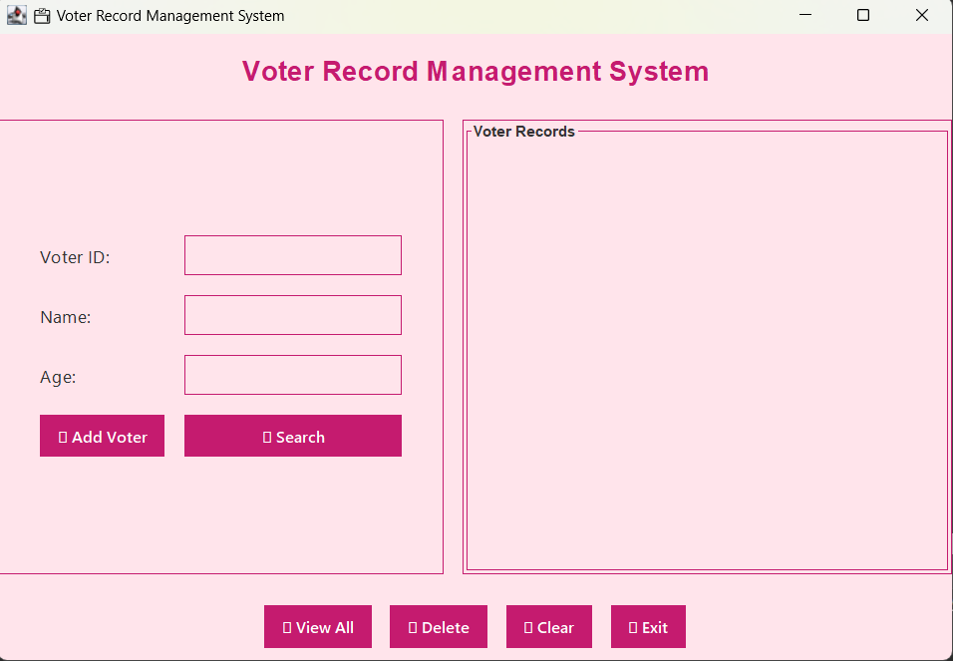

ADD VOTER:
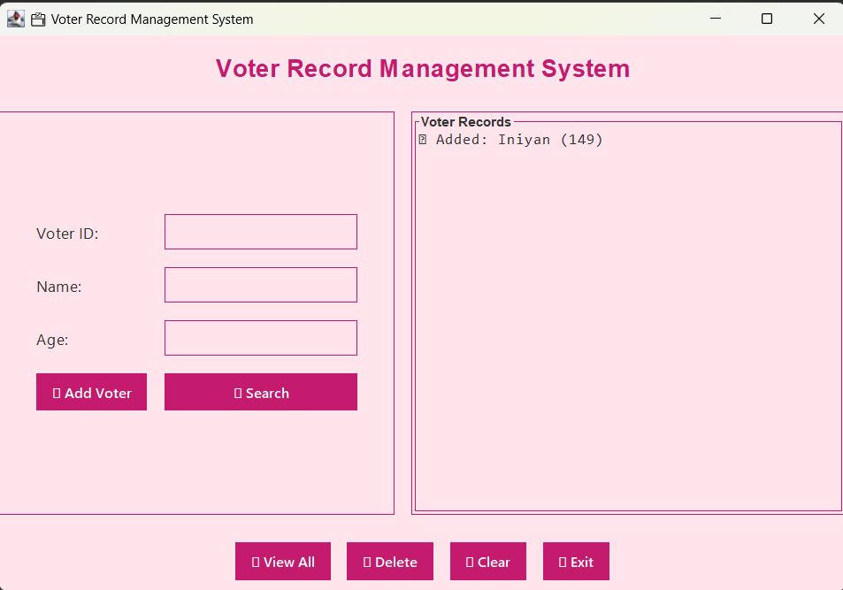

SEARCH VOTER:
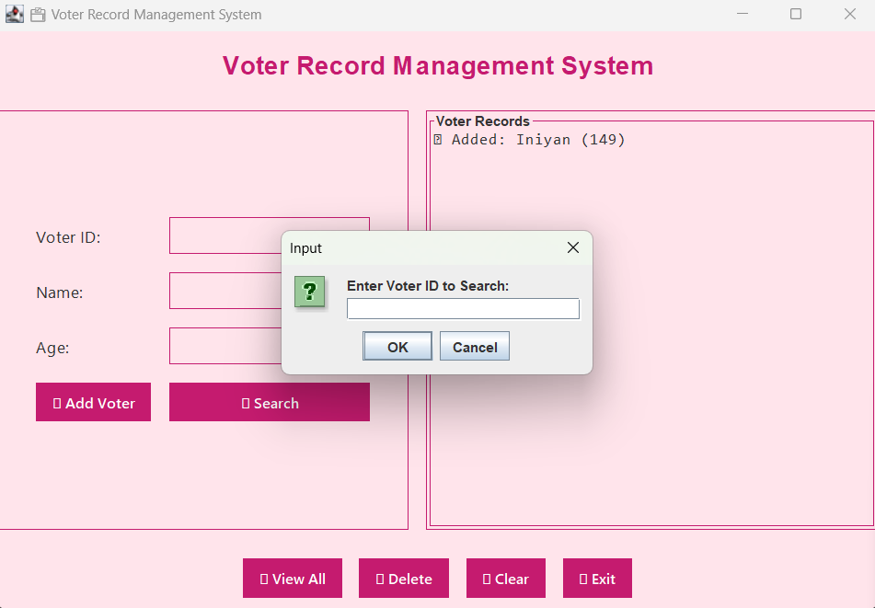

VOTER FOUND:

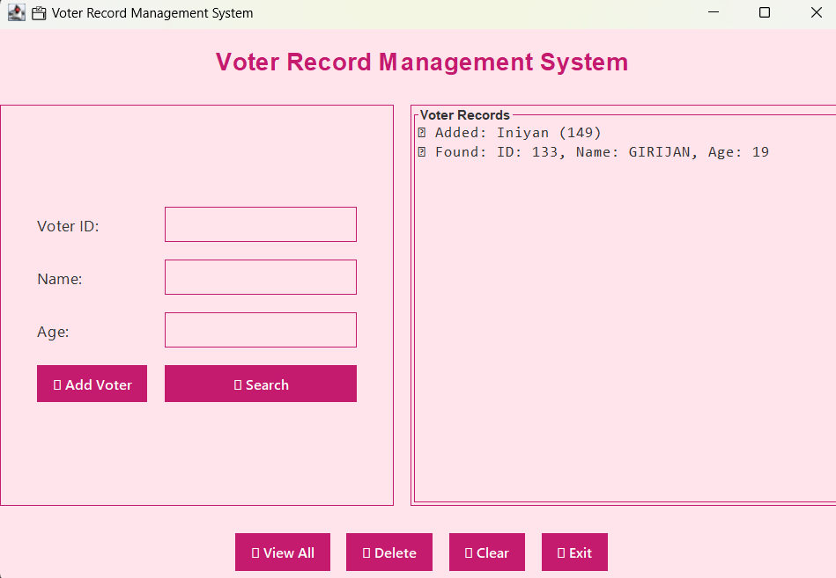

VOTER’S LIST:
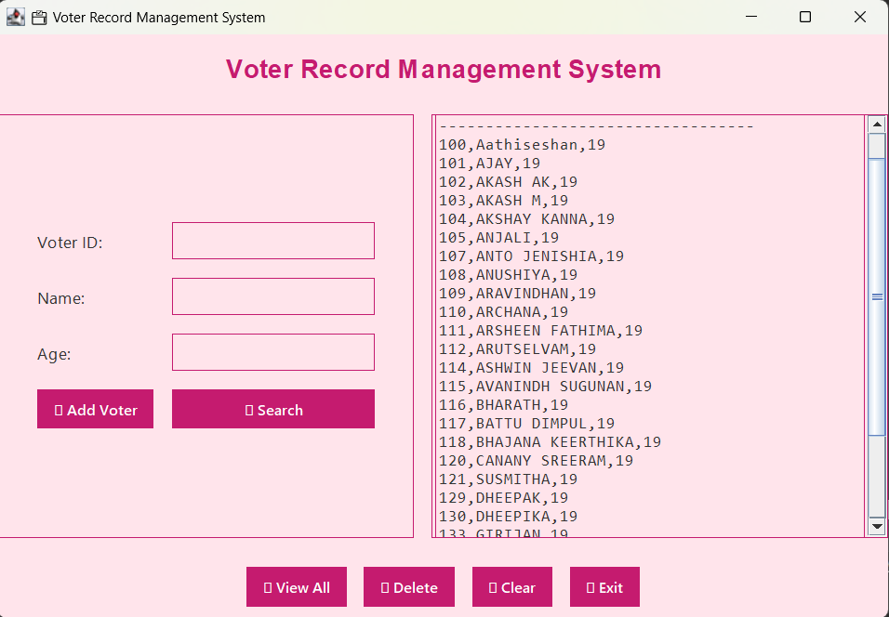

ERROR HANDLING:
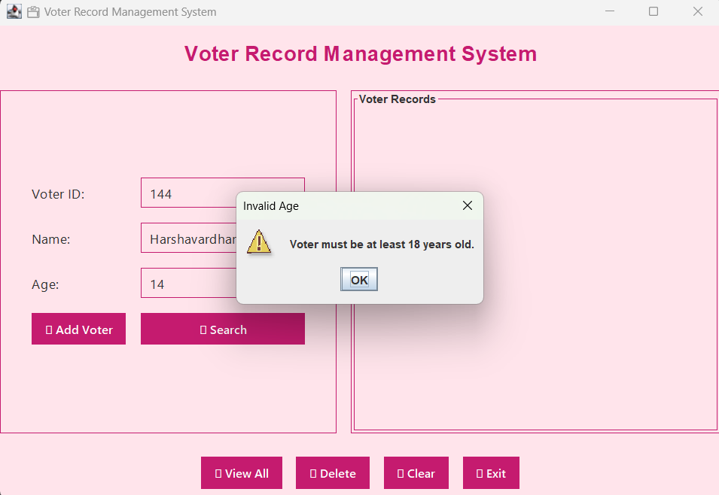
DATABASE:
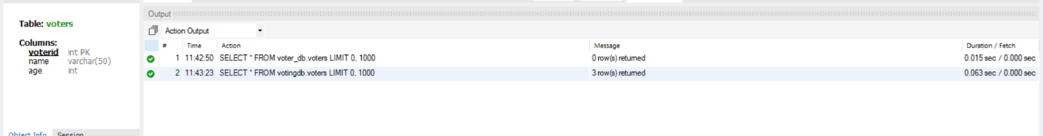

CONCLUSION:
The Voter Record Management System project successfully automates and simplifies the process of managing voter information through an efficient, user-friendly interface.
It demonstrates the use of Java Swing for front-end GUI design and socket programming for real-time client–server communication, ensuring seamless data exchange and reliability.
The system effectively performs operations such as adding, searching, viewing, and deleting voter records, maintaining data integrity and consistency.
It serves as a practical implementation of network programming, multithreading, and GUI-based interaction, showcasing how distributed systems can efficiently handle real-world data management tasks.Overall, the project provides a clear understanding of how technology can be applied to develop secure and scalable voter management solutions.

FUTURE ENHANCEMENT:
- The Voter Record Management System can be improved further by integrating advanced technologies and additional functionalities.
- Biometric authentication such as fingerprint or facial recognition can be added to enhance voter verification and security.
- An OTP-based verification system through SMS or email can be implemented to ensure secure updates and deletions of voter data.
- The system can be expanded to support multiple administrative roles, allowing authorized officials to manage different regions or constituencies.
- Data encryption can be introduced to protect sensitive voter details during transmission and storage.
- Integration with cloud databases can enable scalability, remote access, and centralized data management across multiple locations.
- An AI-based analytics module could be incorporated to detect duplicate or fraudulent voter entries automatically.
- The user interface can be redesigned as a web or mobile application, increasing accessibility and convenience.
- Additionally, the system can generate automated reports and dashboards to help administrators analyze voter data trends efficiently.
- Overall, these enhancements would make the system more secure, scalable, and adaptable to large-scale electoral management.
GITHUB LINK: | https://github.com/Giri6126/Voter-Record-Checker

PO-PSO Mapping Table :
PO1 | PO2 | PO3 | PO4 | PO5 | PO6 | PO7 | PO8 | PO9 | PO10 | PO11 | PO12 | PSO1 | PSO2 | PSO3
3 | 3 | 2 | 3 | 2 | 2 | 2 | 1 | 2 | 2 | 3 | 3 | 3 | 2 | 1

PSO Justification :
PSO | Relevance | Justification
PSO1 – Apply fundamental computing knowledge | 3 | Applied Java networking and Swing concepts to develop a functional voter management system.
PSO2 – Design and implement solutions | 2 | Designed and implemented an interactive client-server architecture using socket programming.
PSO3 – Use modern tools and technologies | 1 | Used Java Swing for the front-end GUI and MySQL/Socket programming for data management and communication.

PO Justification:
PO | Relevance | Justification
PO1 – Engineering Knowledge | 3 | Applied Java programming and networking fundamentals to build a functional Voter Record Management System.
PO2 – Problem Analysis | 3 | Analyzed requirements for voter data handling and implemented an efficient solution.
PO3 – Design/Development of Solutions | 2 | Developed a robust and user-friendly GUI for managing voter operations such as add, search, and delete.
PO4 – Conduct Investigations of Complex Problems | 3 | Tested client-server communication and ensured accurate and consistent voter data exchange.
PO5 – Modern Tool Usage | 2 | Utilized Java Swing, MySQL, and socket programming for system development and communication.
PO6 – The Engineer and Society | 2 | Addressed the need for secure and digital record management in electoral systems.
PO7 – Environment and Sustainability | 2 | Encouraged digital data management to reduce paper-based voter records.
PO8 – Ethics | 1 | Maintained integrity, privacy, and security of voter information throughout the process.
PO9 – Individual and Team Work | 2 | Collaborated effectively in designing, coding, and testing the client-server system.
PO10 – Communication | 2 | Documented system architecture, code design, and functionalities clearly and systematically.
PO11 – Project Management and Finance | 3 | Managed time, resources, and milestones efficiently during project development.
PO12 – Life-long Learning | 3 | Enhanced understanding of networking, multithreading, and GUI programming in Java.

